Dataset 2
Tables created:
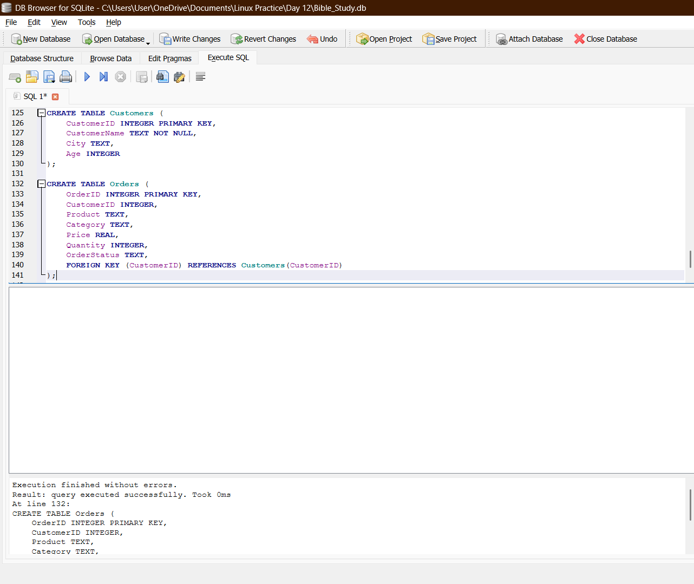

Table Customers:
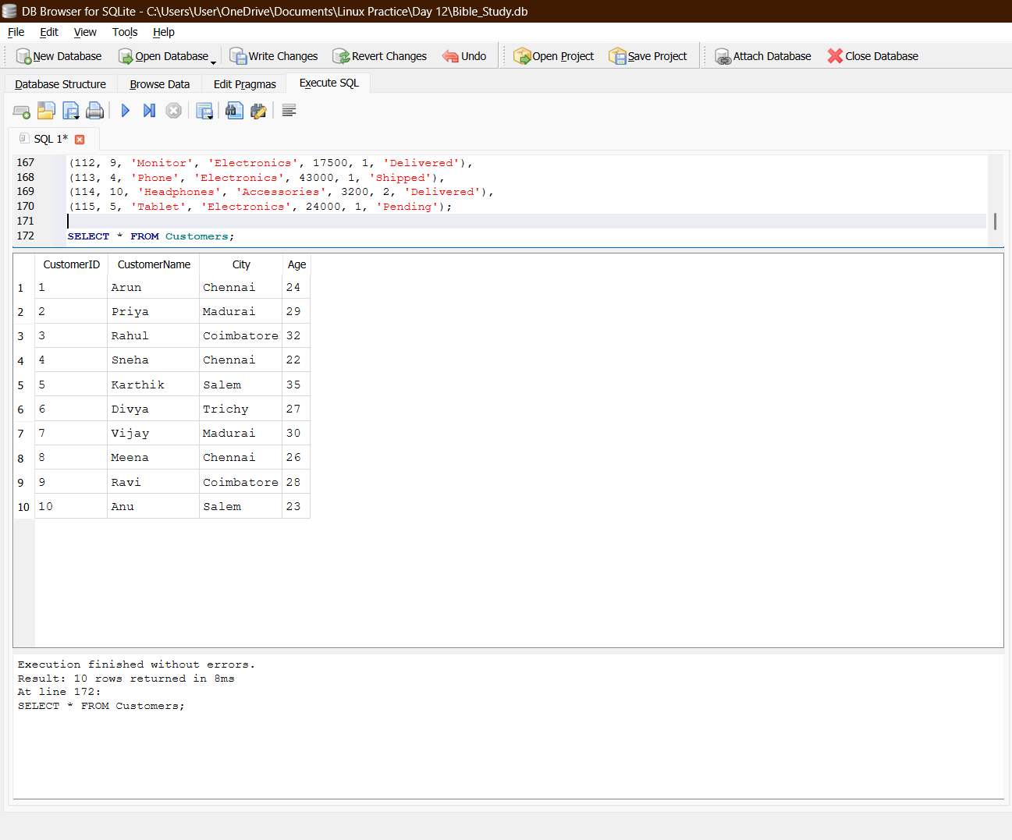

Table Orders:
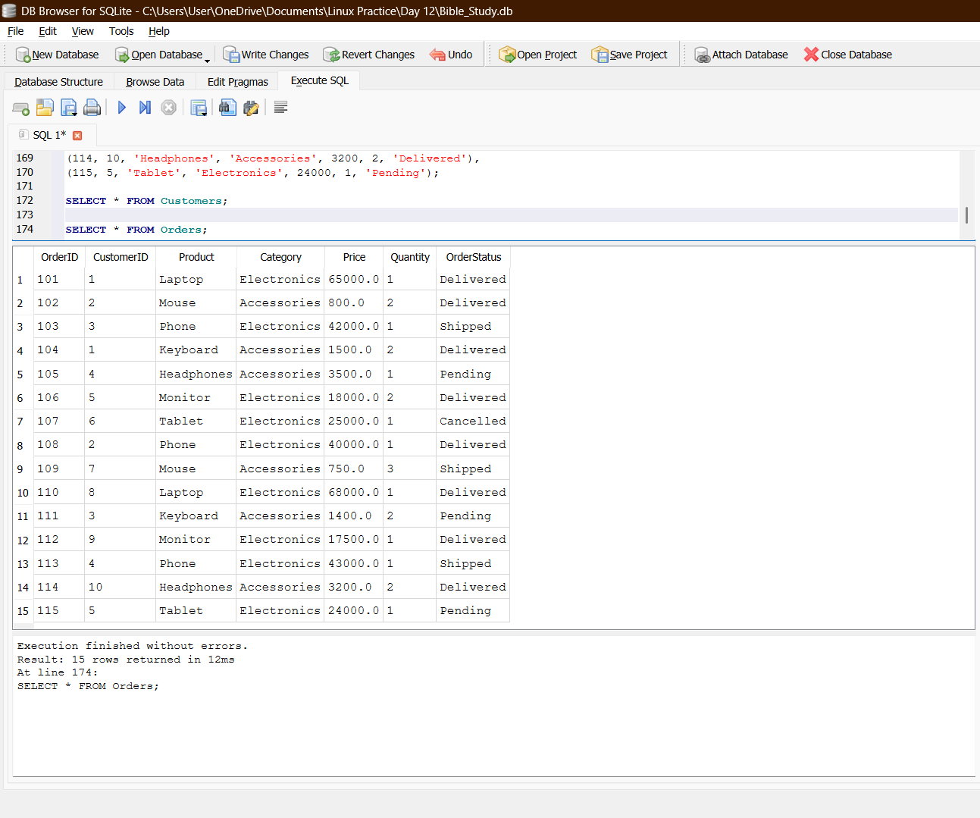

Queries:
- Inner join:
SELECT
Customers.CustomerName,
Customers.City,
Orders.Product,
Orders.OrderStatus
FROM Customers
INNER JOIN Orders
ON Customers.CustomerID = Orders.CustomerID;
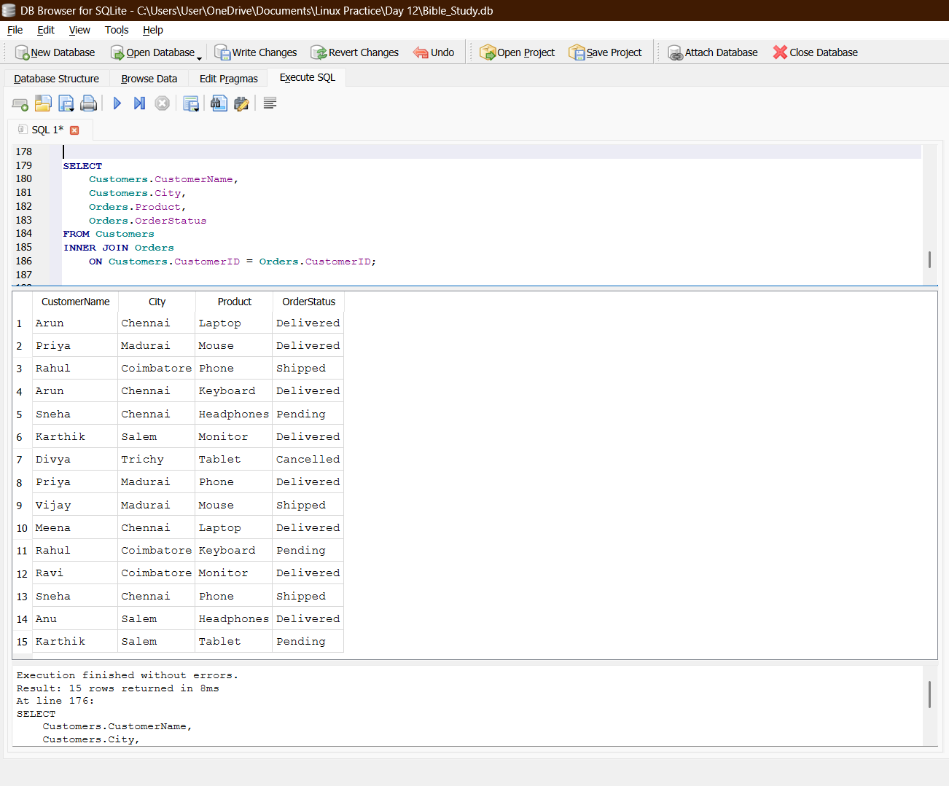

- Where and Order By:
SELECT Product, Price, OrderStatus
FROM Orders
WHERE OrderStatus = 'Delivered'
AND Price > 10000
ORDER BY Price DESC;
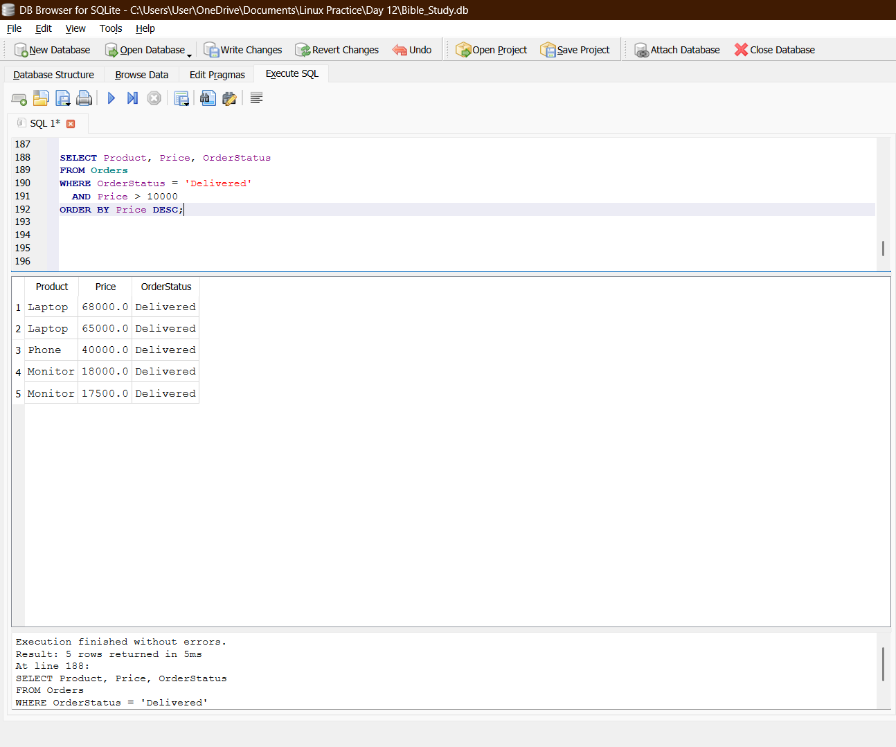

- Group By and Sum():
SELECT
Category,
SUM(Price * Quantity) AS TotalRevenue
FROM Orders
GROUP BY Category
ORDER BY TotalRevenue DESC;
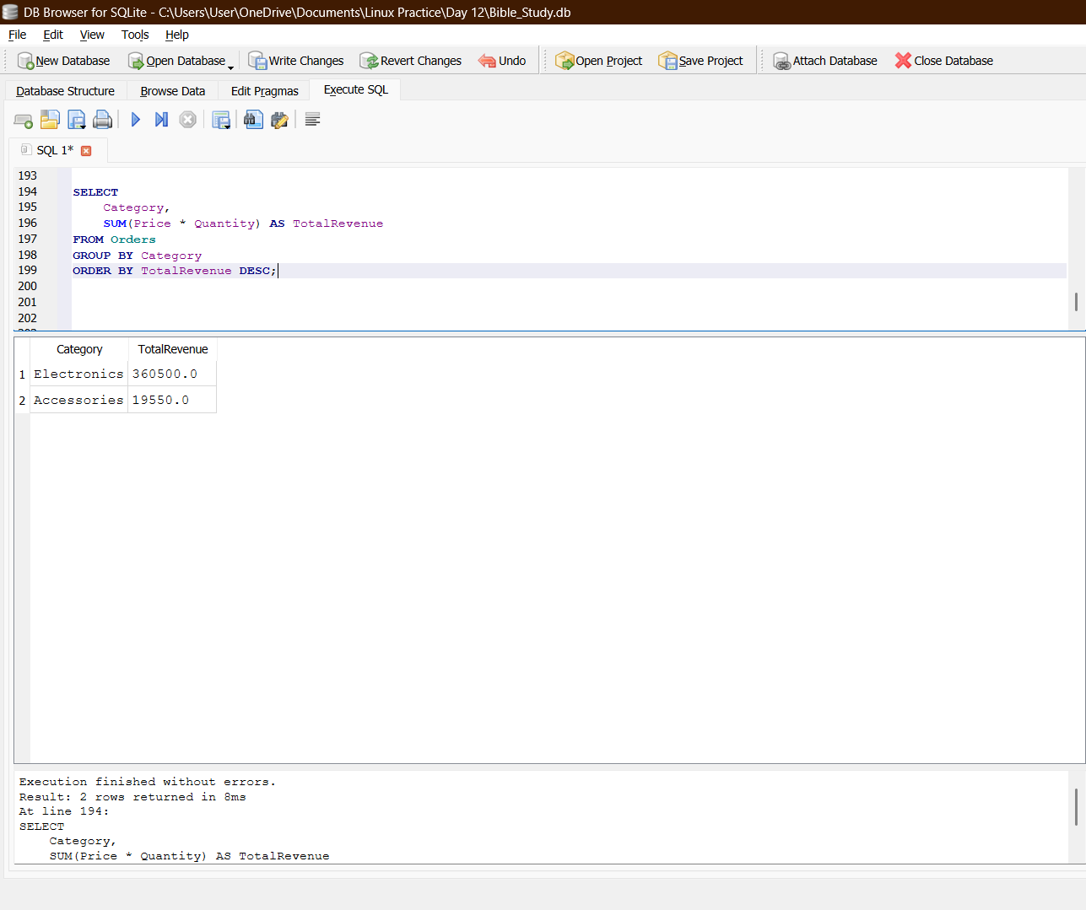

- Group by and Count():
SELECT
Customers.CustomerName,
COUNT(Orders.OrderID) AS TotalOrders
FROM Customers
LEFT JOIN Orders
ON Customers.CustomerID = Orders.CustomerID
GROUP BY Customers.CustomerID, Customers.CustomerName
ORDER BY TotalOrders DESC;
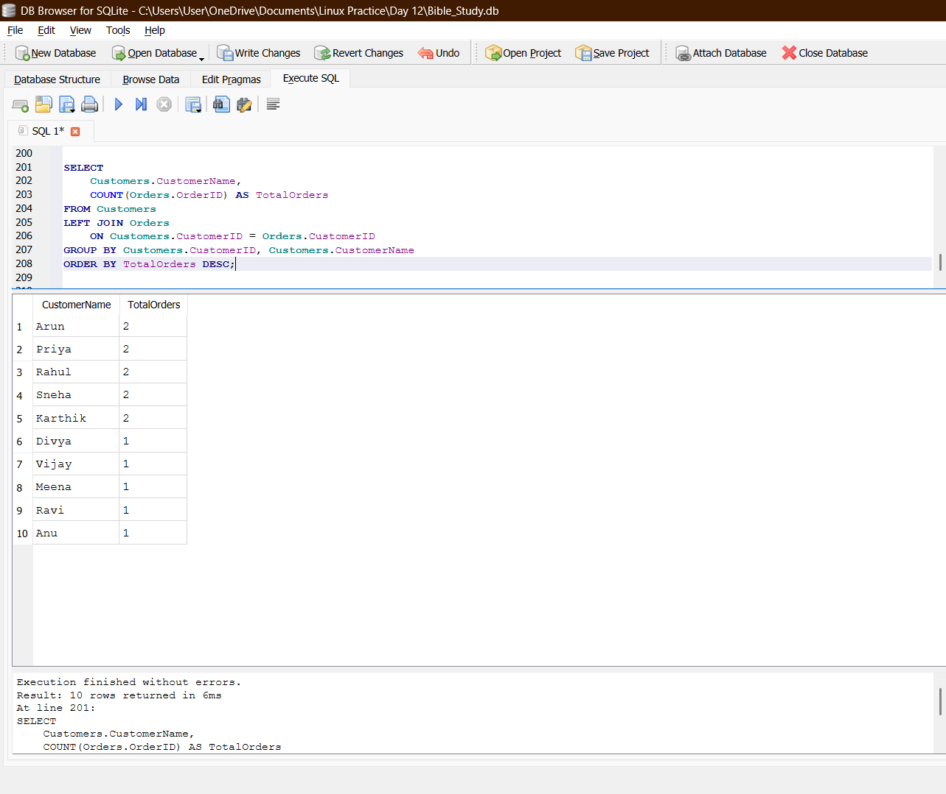

- Having and Avg():
SELECT
Category,
AVG(Price) AS AveragePrice
FROM Orders
GROUP BY Category
HAVING AVG(Price) > 10000;
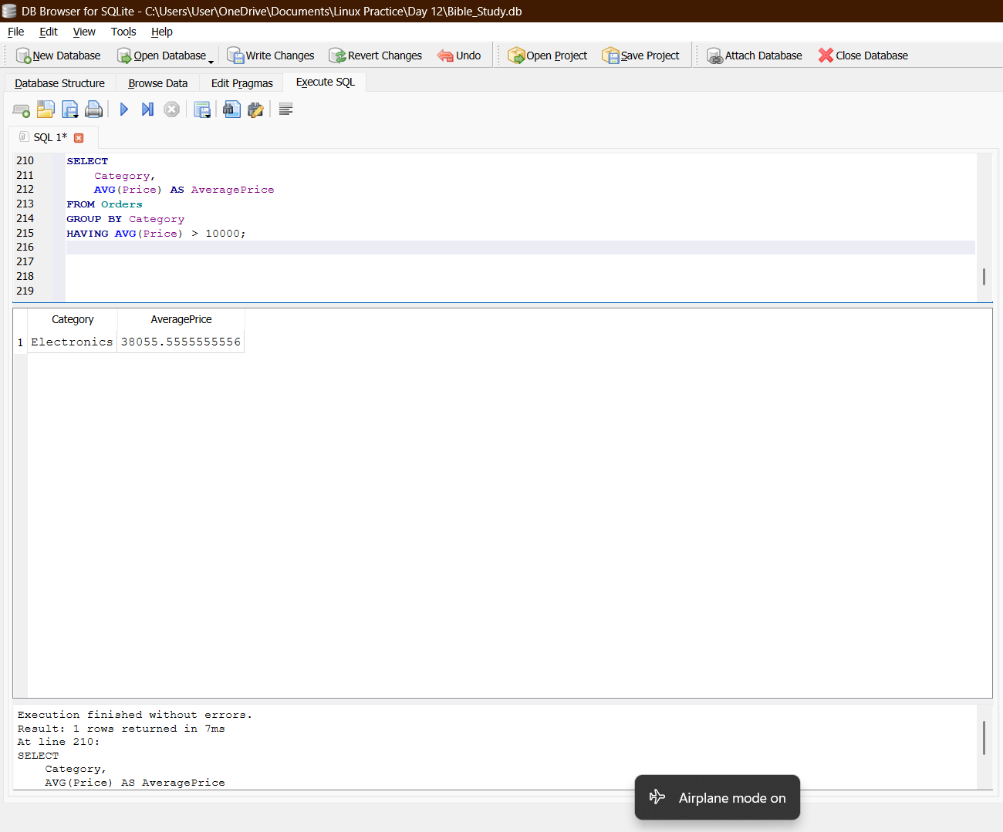

- Left join:
SELECT
Customers.CustomerName,
Orders.OrderID,
Orders.Product
FROM Customers
LEFT JOIN Orders
ON Customers.CustomerID = Orders.CustomerID
ORDER BY Customers.CustomerName;
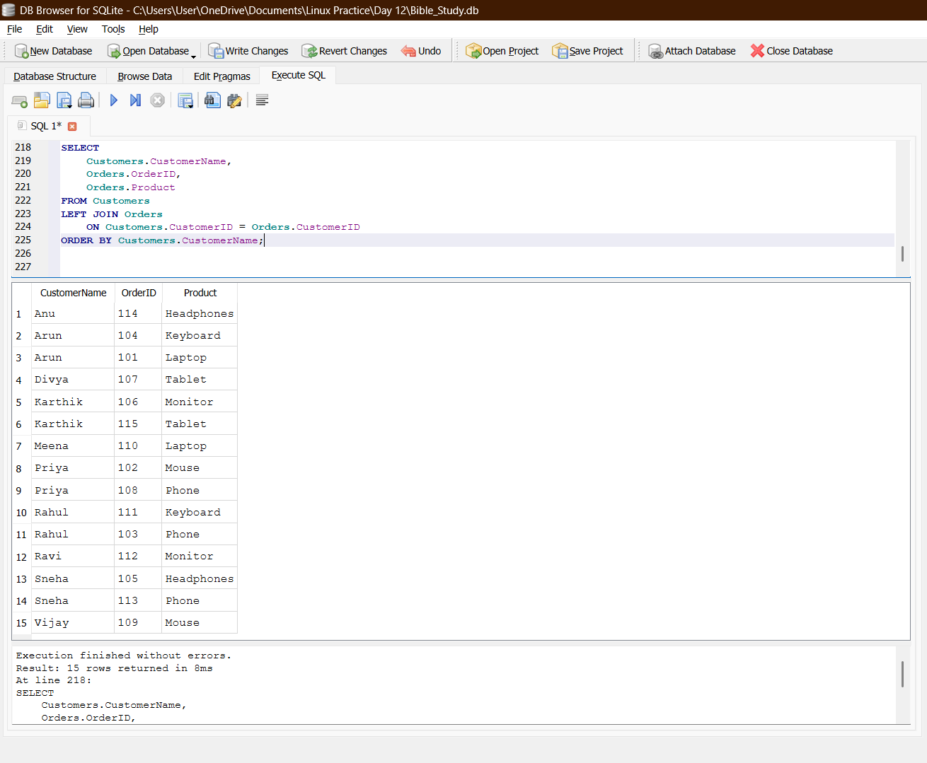

- Subquery:
SELECT Product, Price
FROM Orders
WHERE Price > (
SELECT AVG(Price)
FROM Orders
)
ORDER BY Price DESC;
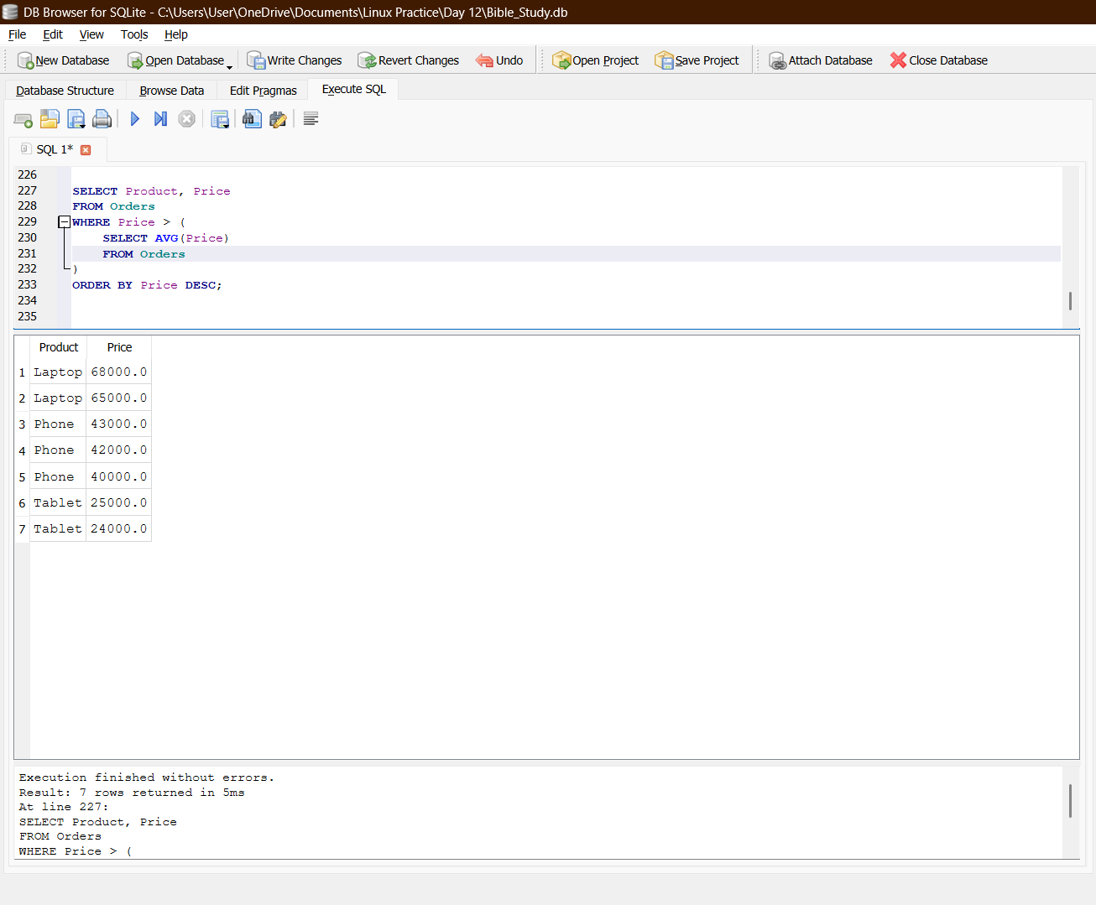

- Revenue calculation:
SELECT
Customers.CustomerName,
Customers.City,
Orders.Product,
Orders.Price,
Orders.Quantity,
Orders.Price * Orders.Quantity AS OrderValue
FROM Customers
INNER JOIN Orders
ON Customers.CustomerID = Orders.CustomerID
WHERE Orders.OrderStatus = 'Delivered'
AND Orders.Price * Orders.Quantity > 20000
ORDER BY OrderValue DESC;
